**Development of A Website-Based Library Information System at LKIA Pontianak School**

**Nikolaus Deskon1, Ade Restu Juliansyah2, Muhammad Ihsan Kamil3,** **Gabriel Arsenius Sandria Umbing4, Yulio Andre Rian Kristian Nitbani5**

1,2,3,4,5IKIPPGRI Pontianak

E-mail: [nikolausdeskon@gmail.com](mailto:nikolausdeskon@gmail.com)1; [aderestuj@gmail.com](mailto:aderestuj@gmail.com)2; [m.ihsankamil38@gmail.com](mailto:m.ihsankamil38@gmail.com)3; [gabrielpnk3@gmail.com](mailto:gabrielpnk3@gmail.com)4; [yulioandrerkn@gmail.com](mailto:yulioandrerkn@gmail.com)5

*Abstract*

*This research intends to develop a* website*-based library information system that is expected to increase the reading interest of Sekoah residents and also make it easier for library staff to work more effectively so that it can improve the literacy skills of LKIA Pontianak school residents. This research is a type of Research and Development or Research and Development (R&D). The purpose of this Research and Development is to produce media in the form of a* website*. The product developed is then tested for feasibility by validating and testing the* website *product. The design of the development of a* website*-based library information system at LKIA Pontianak school uses the ADDIE development model. Validation is carried out to determine the feasibility of the library* website *before it is implemented in the implementation of digital libraries. The validation was carried out by a validator consisting of one system and media expert at the LKIA Pontianak school.The result of the research is the development of a library information system made in the form of a* website *to make it easier for librarians and students to find books such as package books, fiction books and nonfiction books. With this library information system, students can borrow books, be it fiction books, nonfiction books and package books. Where currently LKIA Pontianak School does not have a* website*-based school library information system. For this reason, LKIA Pontianak School needs to implement the School Library Information System.*

***Keywords:*** *Education; Information System; Library Managamen; Pontianak.*

**Abstrak**

Penelitian ini bermaksud untuk mengembangkan sistem informasi perpustakaan berbasis website yang diharapkan dapat meningkatkan minat baca warga Sekoah dan juga memudahkan petugas perpustakaan untuk bekerja lebih efektif sehingga dapat meningkatkan kemampuan literasi warga sekolah LKIA Pontianak. Penelitian ini merupakan jenis penelitian dan pengembangan atau *Research and Development* (R&D). Tujuan dari penelitian dan pengembangan ini adalah untuk menghasilkan media berupa website. Produk yang dikembangkan kemudian dilakukan uji kelayakan dengan melakukan validasi dan uji coba produk website tersebut. Perancangan pengembangan sistem informasi perpustakaan berbasis website di sekolah LKIA Pontianak ini menggunakan model pengembangan ADDIE. Validasi dilakukan untuk mengetahui kelayakan website perpustakaan sebelum diimplementasikan dalam implementasi perpustakaan digital. Validasi dilakukan oleh validator yang terdiri dari satu orang ahli sistem dan ahli media di sekolah LKIA Pontianak. Hasil dari penelitian ini adalah pengembangan sistem informasi perpustakaan yang dibuat dalam bentuk website untuk memudahkan pustakawan dan siswa dalam mencari buku seperti buku paket, buku fiksi dan buku nonfiksi. Dengan adanya sistem informasi perpustakaan ini, siswa dapat meminjam buku baik itu buku fiksi, buku nonfiksi maupun buku paket. Dimana saat ini Sekolah LKIA Pontianak belum memiliki sistem informasi perpustakaan sekolah berbasis website. Untuk itu, Sekolah LKIA Pontianak perlu menerapkan Sistem Informasi Perpustakaan Sekolah.

**Kata-kata kunci:** Pendidikan; Sistem Informasi; Manajemen Perpustakaan; Pontianak.

**INTRODUCTION**

In the era of globalization and competence as a consequence of the learning process, improving and developing the quality of human resources (HR). Competition in the era of globalization that we know that increasingly advanced technological developments must be able to take advantage of technological advances in an effort to produce quality human resources (HR) and be able to compete in the era of globalization.[1]

Along with the rapid development of technology in the current era, so that website The library has resulted in a shift in the delivery of information from the library manually to the digitization of library information through website in the school library.[2] In general, school libraries are a means provided by the school for students, teachers, or school staff in finding books to be studied or used in the teaching and learning process or as a reference for school residents. In this digital era, libraries can also be used as a source of school information. So that the existence of a school library can help support the teaching and learning process.[3] Therefore, the books available in the school library must be complete to make it easier for students and teachers in the teaching and learning process. Therefore, in the procurement of library books, the management should consider the school curriculum and also the needs of students or teachers. To facilitate the distribution of library information, technology is needed that can provide faster access in library management.

Good and proper library management is very important, because it must adjust the needs desired by the school. To carry out the management of the library, technology is needed that can combine all activities into a complete unit and can be used quickly and precisely. The technology is in the form of website school libraries that are integrated with school needs. Site *Web* Libraries are a new form of service offered by digital libraries. The tendency to use electronic information sources, both scientific and non-scientific, which is increasingly widespread, encourages libraries to build websites *Web* library. Definition of the site *Web* Library is one of the services obtained by users in utilizing and exploring the collections owned by a library using the internet network. Site *Web* Libraries usually aim to make it easier for users to find collections owned by a library without having to physically visit the library. In the development of the library world today, there are a lot of minologies regarding websites *Web* library. Related terms that are often used are usually *Electronic Library, Digital Library*, Library Information System Based *Web* (*Web Catalogue*), and so on. However, nowadays the most popular term for site terms *Web* This library is a digital library (*Digital Library*). A digital library is a merger of library information systems through *Web* or electronically with collections in digital form.[4]

According to Ismail said that a digital library is a system consisting of hardware (*Hardware*) and software (*Software*), electronic collection, management staff, users, organizations, work mechanisms, and services by utilizing various types of information technology. A digital library indicates that the collection is in digital form and may not have a printed collection. Digital libraries can be part of libraries in general or stand alone. Digital libraries may also be accessible via the internet (becoming *Virtual Library*) or only available on the local network. Library services on site *Web* providing an explanation of information about the facilities provided by the library for book users and the dissemination of information. While the technical service on the site *Web* Providing information about acquisitions, classifications, cataloging and circulation often comes to view on the library’s website.[5]

LKIA Pontianak School is a private school located on Jl.Jendral Ahmad Yani No.5, Akcaya, South Pontianak District, Pontianak City, West Kalimantan 78113. Basically, the LKIA Pontianak school does not have a digital library, and also the readers in the LKIA Pontianak school library are still relatively low, this can be seen from the library visit book found in the school, which is the location of the research to be carried out. Based on the results of pre-observation conducted at LKIA Pontinanak School, several difficulties were found in processing data, especially in processing data on borrowing and returning books as well as recording book fines that were slow to be returned by students, because the school library was still manual. So that school librarians sometimes experience incorrect data collection, and make librarians not very effective in working, and also sometimes officers forget what types of books are available, as well as the location of books in the library, because with the many types of books available that have not been recorded in detail on the computer, because the data collection is still manual. This results in students and teachers having difficulty finding books that they want to borrow or use quickly in the library. The library at LKIA Pontianak school needs a website-based library information system  to overcome existing problems and provide accurate information about the books available in the library.

From the results of structured interviews conducted with library officers, teachers, and also students of LKIA Pontianak Junior High School, they each said that the LKIA Pontianak school library needs a library information system based on website To make it easier to work for library staff and also to make it easier for teachers or students who are library visitors to find books, borrow books, and return books without having to come directly to the library, but only by accessing the website *Web* What was created is a library information system based on website*.* Therefore, the development of library information systems based on website It is a solution for students and teachers or school staff to find available books more quickly and practically and teachers and students can borrow online through websitelibraries and also make it easier for library staff to be effective in their work.

According to Ferizal and Sobarnas in their research entitled "Library Information System Based on *Web* At Fatahilah Vocational School Cileungsi".[6] In his journal, he said that the research aimed to make a book lending application design based on *Web*, where this designed system can control book stock, make borrowing lists, return lists and make reports. Meanwhile, the difference with the research conducted by the author is that it has the advantage of having a message menu option either logged in as an admin or as a member so that you can convey a message if you want to leave a message, while in the research conducted by Ferizal and Sobamas it is not available. Based on this background, this research is considered important because with the development of a library information system based on website It is hoped that it can increase the reading interest of Sekoah residents and also make it easier for library staff to work more effectively so that they can improve the literacy skills of LKIA Pontianak school residents. Evaluation is carried out at each stage in ADDIE, the stages that must be evaluated are *Analysis, Design, Development, Implementation, Evaluation*. Development website A carefully prepared digital library will go through the stages of ADDIE’s development smoothly and end up at a stage called evaluation.

**METHOD**

This research is a type of *Research and Development* or *Research and Development* (R&D), is a research method used to produce a specific product and test the effectiveness of the method.[7] The purpose of this research is to produce media in the form of a website. The product developed is then tested for feasibility by validating and testing the website product.The design used in this study is the development of a website-based library information system at LKIA Pontianak school using the ADDIE development model.[8] At this stage, the money analysis is carried out is a needs analysis, and the development analysis is presented as an analysis of user needs, namely applying the current perceived situation and conditions, this can be done by identifying the root cause of the needs that the school wants, Carried out by analyzing teachers and library administrators at this stage will know what needs to be developed to facilitate the school and is not yet available The information system used to assist in the search for books in the Complainant’s library is still manual and there are often mistakes in the collection of books in the library, for example book data collection. In the development stage at this development stage, the researcher develops a digital library website according to the design. At this stage of development, activities are carried out by realizing the concept that has been made at the design stage that has been carried out previously. At the Implementation stage, after the website is declared valid, the website is implemented at the LKIA Pontianak school which has been determined as the implementation site. We will not know the result of a website creation if no action is taken. At this stage, the response of students, teachers and library staff is tested to determine the feasibility of the digital library website developed. Then at this stage, a student response questionnaire was also filled out by students. This response questionnaire aims to improve the development of the school library website that is developed. The final stage in this research is the Evaluation stage. Evaluation is carried out at every stage in ADDIE, the stages that must be evaluated are Analysis, Design, Development, Implementation, Evaluation. The development of a carefully prepared digital library website will go through the stages of ADDIE’s development smoothly and end at a stage called evaluation.[9]

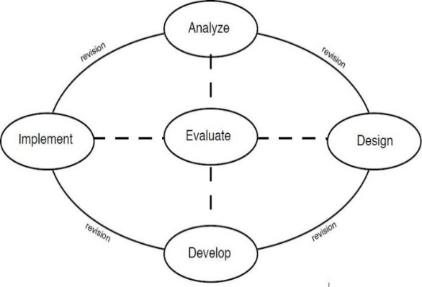

Figure 1. ADDIE’s Development Steps[10]

The framework, which is still conceptual, is listed as a library website that is ready to be implemented. The development stage of the school library website, the stage of learning tool development in this study includes system validators and content validators.

**RESULTS AND DISCUSSION**

The development of library information systems is a website created to make it easier for librarians and students to find books such as package books, fiction books and non-fiction books. With this library information system, students can borrow books, be it fiction books, nonfiction books or package books.[11] Where currently LKIA Pontianak School does not have a website-based school library information system. For this reason, LKIA Pontianak School needs to implement the School Library Information System. So it is hoped that it can make it easier for librarians to record books such as borrowing, returning and fines. The specifications required in the creation of a School Library Information System must have the ability to store, organize, and manage various types of book borrowing, book returns, and fines. Several similar studies have been conducted by Ferijal, the library system must be managed properly in order to provide the best possible benefits to users.[12] Another research was also conducted by Nurul Alifah that the school library is a resource that can be used by school students and the system must provide easy and safe access for users**.** Other research also says that school libraries are a reference source that students and teachers can use to add knowledge.[13]The School Library uses the PHP (*Haypertaxt Preprocessor*) programming language supported by a browser designed in such a way. In general, PHP (*Haypertaxt Preprocessor*) capabilities provide reliable programming components and languages that make it possible to create applications according to the desired look and capabilities.*A flowchart* is a diagram that displays the steps and decisions to carry out a process of a program. Each step is depicted in the form of a diagram and is connected by a line or arrow direction.

*Flowcharts* play an important role in deciding the steps or functionality of a program creation project that involves many people at once. In addition, using a process flow chart of a program will be clearer, more concise, and reduce the possibility of misinterpretation. The use of *flowcharts* in the world of programming is also a great way to connect between technical and non-technical needs. The main function of a *flowchart* is to give an overview of the course of a program from one process to another. Thus, the flow of the program becomes easy for everyone to understand. In addition, another function of the *flowchart* is to simplify the series of procedures to make it easier to understand the information. *A system flowchart* is a type of flowchart that displays the entire stages or work processes that are taking place in the system.[14]

This type of *flowchart* does not always explain each process in detail, but only displays the sequence of processes and media used.

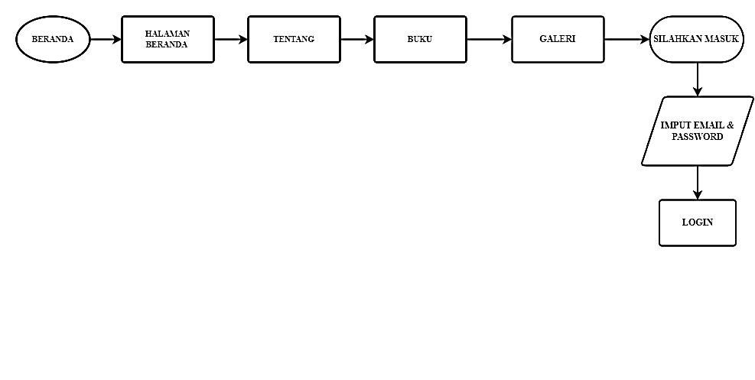

Figure 2.  *School Library Information System Flowchart*

*The flowchart*  of the school library information system is the main flowchart, there are series in the initial display in the school library where there is a homepage and about is a place to introduce yourself to the school library, the principal’s remarks, library rules, the visions and missions of the school library, and finally the location of the school.[15] Then there are books to see that there are several books in the LKIA Pontianak school library, then the gallery is a place where when children are reading in the library can also include photos of teachers and photos of library staff. Then there is a login, enter an email and password, then log in as an admin or member.

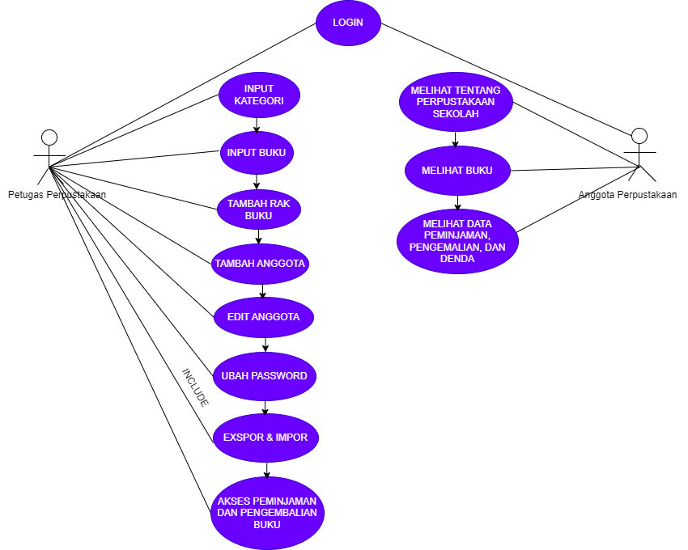

Figure 3.  *Web-Based* School Library *Use Cases*

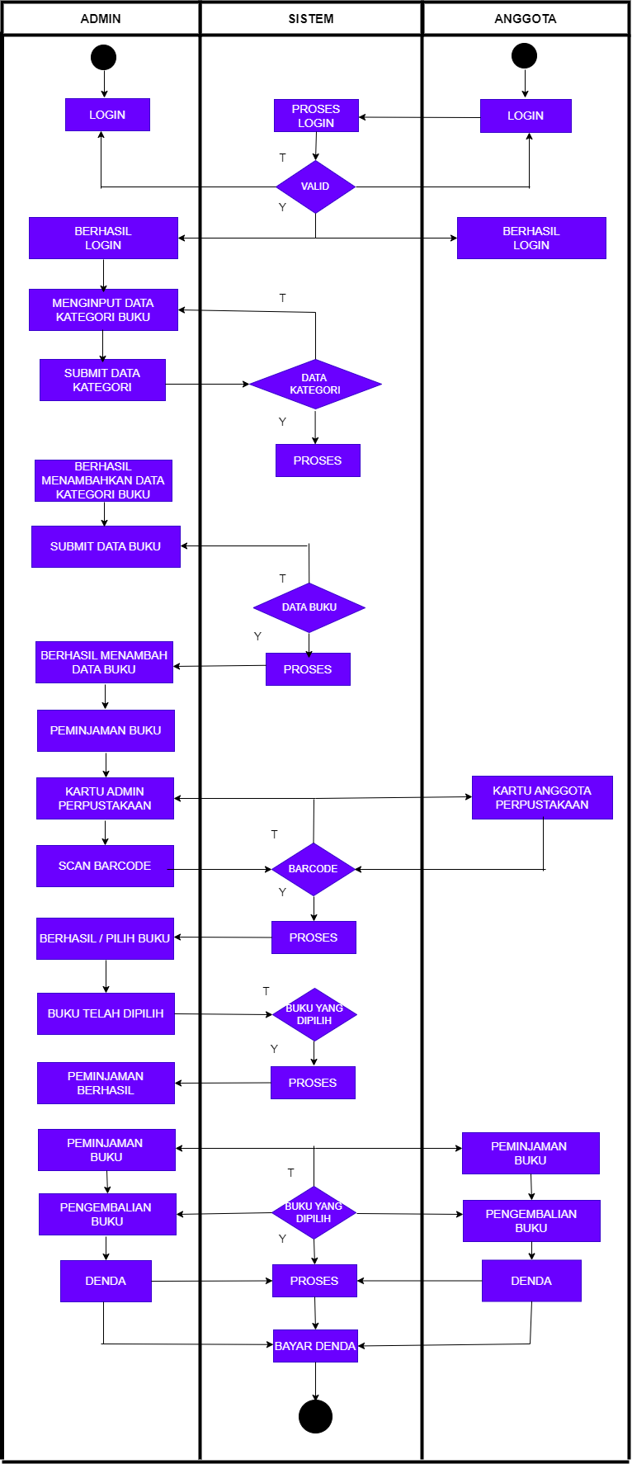

Figure 4. *Activity Diagram of Admin* and Member lending, return and

Book fines

The initial stage that is carried out is that the admin and members log *in* first, then the system will detect whether the login is valid if the *login* is successful, then it can input the category data form where there is the name of the book category and the book sequence number, then if it is right, it will submit the category data form, then the form will be processed by the system if successful, the system will give a successful notification add category data, then in the book data section there is the title of the book, the author of the book, the year of publication of the book, the publisher of the book, ISBN and the book cover, after that if you have filled in the order correctly, you will be able to submit the book data form and if it is successful, the system will provide information that you have successfully added the book data, finally the book will appear in the user and will be able to get information and borrow books from library members if you borrow books must first be from the admin to In the scan of the membership card containing each member, there is a barcode. After that the admin inputs what the member wants to borrow after that it is submitted and there are several, namely book borrowing, book return and fines. If members are late in returning books, they will get a fine according to the delay.

**Interface Design**

Interface design includes designing menu structure and designing the display on the user view. *User Interface* (UI) design is the process that designers use to create displays in computerized software or devices, with a focus on appearance or style. The goal of a UI designer is to create an interface design that makes users easy to use and enjoyable.[16]

Figure 5. Design of the *Home Menu Interface*

In the image above there are many menus, namely library information systems*,* homepages, About, Books, Gallery, please login.

Figure 6. About Menu Interface Design

About is explaining the library rules, remarks by the head of the foundation, the vision and mission of the library and the location of the library of LKIA Pontianak School.

**CONCLUSION**

The development of a website-based library information system can greatly benefit the LKIA Pontianak School by streamlining their library management processes and enhancing the user experience for both students and staff. By leveraging the capabilities of web-based applications, the proposed system can integrate critical library functions such as circulation, inventory, acquisition, and cataloging into a single platform. This centralized approach will enable librarians to work more efficiently, as they will no longer be constrained to a single computer or laptop. The system can also incorporate features that allow users to easily search for and locate desired materials within the library, reducing the frustration often encountered when navigating the physical library space. One such feature could be the integration of a geographic information system (GIS), which would provide users with a visual map of the library’s layout, complete with the precise locations of books and other resources. Furthermore, the system’s ability to handle user reservations, due date notifications, and overdue item tracking can enhance the overall library experience, ensuring that students and staff have the necessary resources at their fingertips.

The implementation of this website-based library information system at LKIA Pontianak School has the potential to revolutionize the way the library operates, leading to increased efficiency, improved user satisfaction, and better stewardship of the institution’s valuable resources. By embracing this innovative approach to library management, the school can position itself as a leader in the integration of technology and education, setting a precedent for other educational institutions to follow.In today’s rapidly evolving digital landscape, the integration of technology into educational institutions has become a necessity, as it provides numerous opportunities to enhance learning, streamline administrative processes, and foster greater engagement among students and faculty. The development of a website-based library information system at LKIA Pontianak School is a prime example of how technology can be leveraged to improve the overall functionality and accessibility of the school’s library resources.

**REFERENSI**

Ade Ajie Ferizal, Mohamad Anas Sobarnas, dan Djoko nursanto. “Sistem Informasi Perpustakaan Berbasis Web di SMK Fatahillah Cileungsi.” *INFOTECH : Jurnal Informatika & Teknologi* 2, no. 2 (Desember 2021): 104–113.

Akeriwa, Miriam, Cecilia Penzhorn, dan Marlene Holmner. “Using Mobile Technologies for Social Media Based Library Services at the University of Development Studies Library, Ghana.” *Information Development* 31, no. 3 (2015): 284–293. https://journals.sagepub.com/doi/abs/10.1177/0266666913515898.

Ferizal, Ade Ajie, Mohamad Anas Sobarnas, dan Djoko Nursanto. “Sistem Informasi Perpustakaan Berbasis Web di SMK Fatahillah Cileungsi.” *INFOTECH: Jurnal Informatika dan Teknologi* 2, no. 2 (2021): 104–113. https://jurnal.sttmcileungsi.ac.id/index.php/infotech/article/view/178.

Khan, Rizwan. “Fatigue Durability Assesment of Suspended Piping Systems Under Random Loads.” *Journal of Materials Science & Surface Engineering* 3, no. 3 (2015): 272–279. chrome-extension://efaidnbmnnnibpcajpcglclefindmkaj/https://www.jmsse.in/files/6 rizwan et al.pdf.

Martatiyana, Diana Rossa, Herlina Usman, dan Hasanah Dewi Lestari. “Application of The Addie Model in Designing Digital Teaching Materials.” *JPPGuseda: Jurnal Pendidikan dan Pengajaran Guru Sekolah Dasar* 6, no. 1 (2023): 105–109. https://journal.unpak.ac.id/index.php/JPPGuseda/article/view/7525.

Mulyana, Asep, Dani Rohpandi, Egi Badar Sambani, Miftah Fahmi, Nono Sudarsono, dan Mohammad Hamdani. “Web-Based Library Information System Design Study at Pasundan 7 Junior High School, Bandung.” *Infotmatics Management, Engineering, and Information System Journal* 1, no. 1 (2023): 77–87. https://jurnal.stmik-mi.ac.id/index.php/imeisj/article/view/224.

Prawastiyo, Cerah Ayunda, dan Indra Hermawan. “Pengembangan Front-End Website Perpustakaan Politeknik Negeri Jakarta dengan Menggunakan Metode User Centered Design.” *Information Science and Library* 1, no. 2 (2020): 1–11. https://journals.usm.ac.id/index.php/jisl/article/view/2784.

Rahmawati, Nurul Alifah. “Evaluasi sistem otomasi IBRA V6 di Perpustakaan SDIT Luqman Al-Hakim Internasional Yogyakarta.” *Jurnal Kajian Informasi dan Perpustakaan* 6, no. 1 (2018): 1–14. https://jurnal.unpad.ac.id/jkip/article/view/14255.

Siregar, Parlindungan, dan Naomi Haswanto. “Designing User Interface (UI) & User Experience (UX) Mobile Website Templates Digital Wedding Invitations.” *IJVCDC: Indonesian Journal of Visual Culture, Design and Cinema* 2, no. 2 (2023): 178–185. https://journal.binus.ac.id/index.php/ijvcdc/article/view/10756.

Sugiyono. *Metode Penelitian Kualitatif Kuantitatif dan R and D*. Bandung: Alfabeta, 2014.

———. *Metode Penelitian Pendidikan Pendekatan Kuantitatif, Kualitatif dan R&D*. Bandung: Alfabeta, 2013.

Tang, Kevin S., Derrick L. Cheng, Eric Mi, dan Paul B. Greenberg. “Augmented Reality in Medical Education: A Systematic Review.” *CMEJ: Canadian Medical Education Journal* 11, no. 1 (2020): 81–96. https://journalhosting.ucalgary.ca/index.php/cmej/article/view/61705.

Wicaksono, Aji. “Digital Library Information System at Brebes Boarding School Vocational High School.” *Journal Research of Social Science, Economics and Management* 1, no. 4 (2021): 333–339. https://jrssem.publikasiindonesia.id/index.php/jrssem/article/view/30.

Young, Scott Woodward Hazard, dan Doralyn Rossmann. “Building Library Community Through Social Media.” *ITAL: Information Technology and Libraries* 34, no. 1 (2015): 20–37. https://ital.corejournals.org/index.php/ital/article/view/5625.

Zalukhu, Agustinus, Swingly Purba, dan Dedi Darma. “Perangkat Lunak Aplikasi Pembelajaran Flowchart.” *Jurnal Teknologi, Informasi dan Teknologi* 4, no. 1 (2023): 61–70. https://ejurnal.istp.ac.id/index.php/jtii/article/view/351.

1. Kevin S. Tang et al., “Augmented Reality in Medical Education: A Systematic Review,” *CMEJ: Canadian Medical Education Journal* 11, no. 1 (2020): 81–96, https://journalhosting.ucalgary.ca/index.php/cmej/article/view/61705.
2. Cerah Ayunda Prawastiyo dan Indra Hermawan, “Pengembangan Front-End Website Perpustakaan Politeknik Negeri Jakarta dengan Menggunakan Metode User Centered Design,” *Information Science and Library* 1, no. 2 (2020): 1–11, https://journals.usm.ac.id/index.php/jisl/article/view/2784.
3. Scott Woodward Hazard Young dan Doralyn Rossmann, “Building Library Community Through Social Media,” *ITAL: Information Technology and Libraries* 34, no. 1 (2015): 20–37, https://ital.corejournals.org/index.php/ital/article/view/5625.
4. Miriam Akeriwa, Cecilia Penzhorn, dan Marlene Holmner, “Using Mobile Technologies for Social Media Based Library Services at the University of Development Studies Library, Ghana,” *Information Development* 31, no. 3 (2015): 284–293, https://journals.sagepub.com/doi/abs/10.1177/0266666913515898.
5. Rizwan Khan, “Fatigue Durability Assesment of Suspended Piping Systems Under Random Loads,” *Journal of Materials Science & Surface Engineering* 3, no. 3 (2015): 272–279, chrome-extension://efaidnbmnnnibpcajpcglclefindmkaj/https://www.jmsse.in/files/6 rizwan et al.pdf.
6. Ade Ajie Ferizal, Mohamad Anas Sobarnas, dan Djoko Nursanto, “Sistem Informasi Perpustakaan Berbasis Web di SMK Fatahillah Cileungsi,” *INFOTECH: Jurnal Informatika dan Teknologi* 2, no. 2 (2021): 104–113, https://jurnal.sttmcileungsi.ac.id/index.php/infotech/article/view/178.
7. Sugiyono, *Metode Penelitian Kualitatif Kuantitatif dan R and D* (Bandung: Alfabeta, 2014).
8. Sugiyono, *Metode Penelitian Pendidikan Pendekatan Kuantitatif, Kualitatif dan R&D* (Bandung: Alfabeta, 2013).
9. Diana Rossa Martatiyana, Herlina Usman, dan Hasanah Dewi Lestari, “Application of The Addie Model in Designing Digital Teaching Materials,” *JPPGuseda: Jurnal Pendidikan dan Pengajaran Guru Sekolah Dasar* 6, no. 1 (2023): 105–109, https://journal.unpak.ac.id/index.php/JPPGuseda/article/view/7525.
10. Sugiyono, *Metode Penelitian Kualitatif Kuantitatif dan R and D*.
11. Asep Mulyana et al., “Web-Based Library Information System Design Study at Pasundan 7 Junior High School, Bandung,” *Infotmatics Management, Engineering, and Information System Journal* 1, no. 1 (2023): 77–87, https://jurnal.stmik-mi.ac.id/index.php/imeisj/article/view/224.
12. Ade Ajie Ferizal, Mohamad Anas Sobarnas, dan Djoko nursanto, “Sistem Informasi Perpustakaan Berbasis Web di SMK Fatahillah Cileungsi,” *INFOTECH : Jurnal Informatika & Teknologi* 2, no. 2 (Desember 2021): 104–113.
13. Nurul Alifah Rahmawati, “Evaluasi sistem otomasi IBRA V6 di Perpustakaan SDIT Luqman Al-Hakim Internasional Yogyakarta,” *Jurnal Kajian Informasi dan Perpustakaan* 6, no. 1 (2018): 1–14, https://jurnal.unpad.ac.id/jkip/article/view/14255.
14. Agustinus Zalukhu, Swingly Purba, dan Dedi Darma, “Perangkat Lunak Aplikasi Pembelajaran Flowchart,” *Jurnal Teknologi, Informasi dan Teknologi* 4, no. 1 (2023): 61–70, https://ejurnal.istp.ac.id/index.php/jtii/article/view/351.
15. Aji Wicaksono, “Digital Library Information System at Brebes Boarding School Vocational High School,” *Journal Research of Social Science, Economics and Management* 1, no. 4 (2021): 333–339, https://jrssem.publikasiindonesia.id/index.php/jrssem/article/view/30.
16. Parlindungan Siregar dan Naomi Haswanto, “Designing User Interface (UI) & User Experience (UX) Mobile Website Templates Digital Wedding Invitations,” *IJVCDC: Indonesian Journal of Visual Culture, Design and Cinema* 2, no. 2 (2023): 178–185, https://journal.binus.ac.id/index.php/ijvcdc/article/view/10756.